**PROBLEM - SOLUTION FIT**



**PROJECT TITLE: “PLASMA DONOR APPLICATION”**

# Team ID: PNT2022TMID47116

**Team Leader: MUTHULAKSHMI S**

**Team member: DEEPIKA M**

**Team member: KAVIPRIYA R**

**Team member: SRILEKA R**

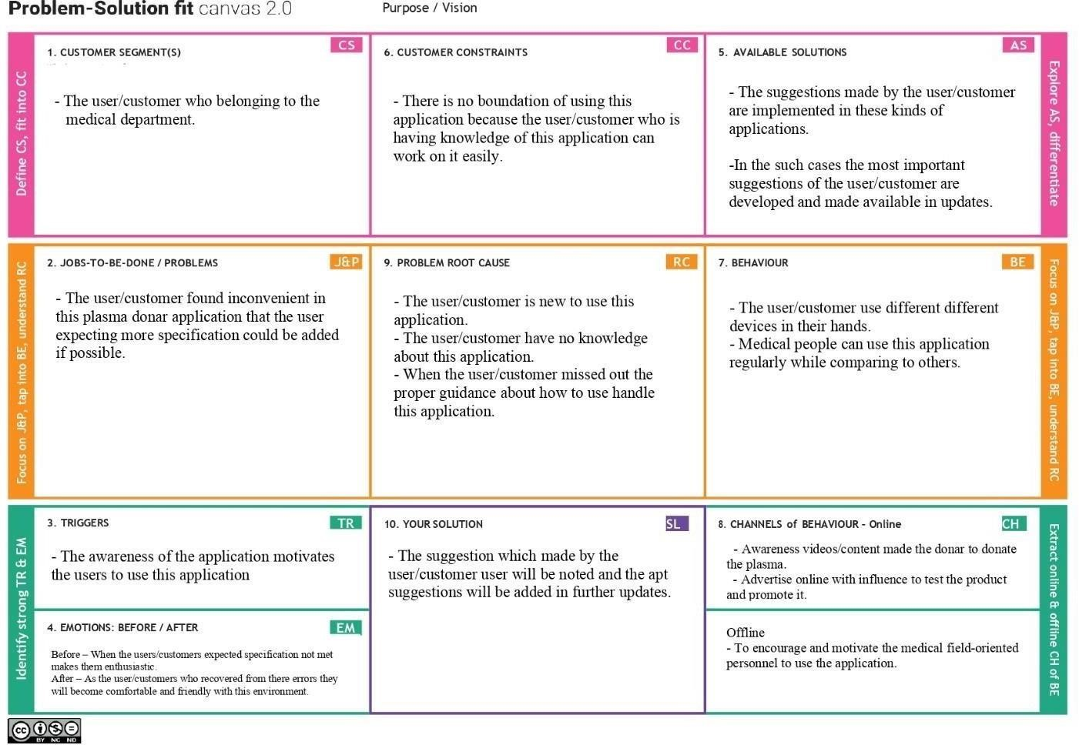

# Team ID: PNT2022TMID47116

# Team ID: PNT2022TMID47116

# Team ID: PNT2022TMID47116

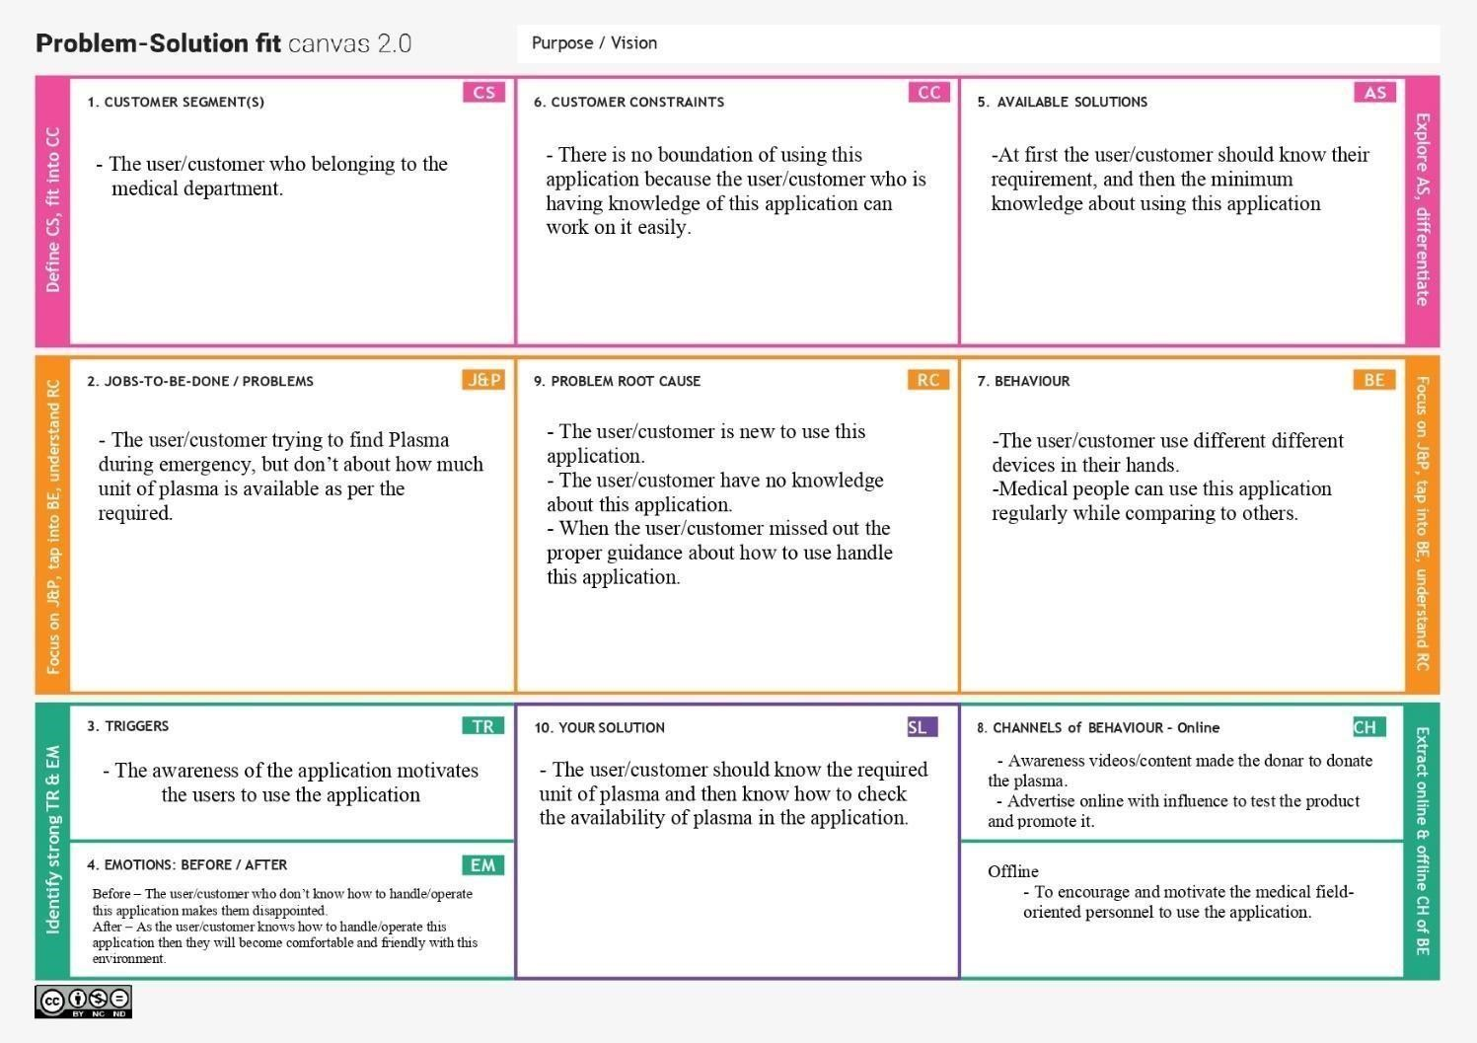

# Team ID: PNT2022TMID47116